**Change your background in Microsoft Teams meetings**

If you want to change what appears behind you in your video meeting or call, you can either blur your background, replace it entirely with any image you want, or use [Teams virtual background template](https://templates.office.com/tm56095562). And with a Teams Premium license, you can change your Teams meeting background to a [branded logo or image](https://support.microsoft.com/en-us/office/use-meeting-themes-for-teams-meetings-fbfd826d-1112-4790-918a-5a82cac8250e) specific to your company.

**Note:**Blurring or replacing your background might not prevent sensitive information from being visible to other people in the call or meeting.

Change your background before a meeting starts:

Your background will persist in all your meetings and calls until you change it again.

1. While you're setting up your video and audio before joining a meeting, turn on your camera and select **Background filters** Background settings.   
   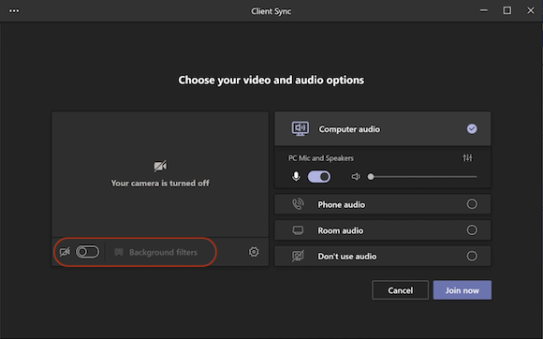
2. Select **Blur**to blur your background. You'll appear nice and clear while everything behind you is subtly concealed.   
   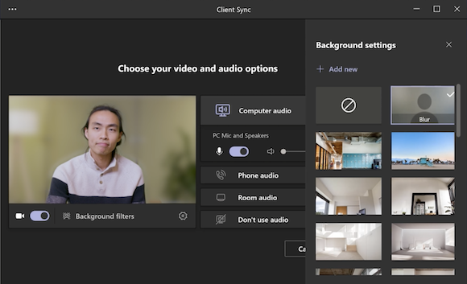  
     
   You can also replace your background with one of the images provided, or with one of your own choosing. To use an image of your own, select **Add new** and then select one to upload from your computer. Make sure it's a .JPG, .PNG, or .BMP file.

To turn off background effects, select **None**  Option for turning off background effect.

**Note:**If you don't see this option in the menu, the feature might not be available on your device.

**How To Change your background in your zoom meetings:**

Click on arrow where your camera icon is.

Click Choose background.

There is a plus sign in the menu under virtual backgrounds. Add the photo attached.

Uncheck the box “Mirror My video”













